Biomolecules Graphic Organizer

Type of Biomolecule | Function | Structure | Types and Examples
Carbohydrates  Elements: |  | 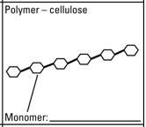
Lipids  Elements: |  | 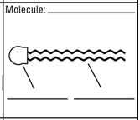
Proteins  Elements: |  | 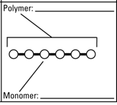
Nucleic Acids

Elements:

